**Does the Amount of Salt in Water Cause Water to Take Longer to Boil?**

Therese M. Parks

Western Governors University

**Section I: Introduction and Literature Review**

1. I learned how to cook from a very early age from mother and older sisters. We cooked a lot of rice and noodles. I was taught to sprinkle salt into the pot of water as part of the boiling process for cooking. Sometimes I added more salt, and other times I added less salt, without really knowing *why* I was putting it in the pot to begin with. I’ve heard so many theories about why people put salt in water to boil. Some say that salt makes water boil faster, and others say it softens the water for the noodles or rice. For this experiment I will be focusing on the amount of salt that I add to the water and how long it takes for the water to boil.

After doing some research, I found that there is one main way that salt effects boiling water - *salt increases the boiling point of water*.

Although the boiling point of water is raised when salt is added to it, there is still some controversy over whether this phenomenon would make the water take a shorter or a longer time to boil. One viewpoint is that **adding salt to water will increase the boiling point of water, but will not cook pasta any faster (Kruszelnicki, 2019). The other viewpoint is that even though the boiling point is increased by adding salt to water, salt water boils more quickly (Helmenstine, 2018). However, both viewpoints agree on the fact that salt increases that boiling point of water.**

Therefore, from the research I was able to determine that adding salt to water, does affect

the boiling water, by increasing it.

**Section II: Hypothesis**

B. My hypothesis: The more salt that is added to water before boiling it, the longer it will take for the water to boil.

C.  I am basing my hypothesis on the research that states that adding salt to water increases the boiling point, which makes the water take a longer time to boil. Since the water must reach a higher boiling point, it makes sense that it would take longer to boil. (**Kruszelnicki, 2019).**

**Section III: Methods**

D. The *independent variable* which I am using for this experiment is salt (Morton ® iodized). I have four bottles of water, each with equal amounts of water, and into the water from each bottle, I will pour a separate measurement of salt. The four salt measurements will equal, ¼ teaspoon, ½ teaspoon, 1 teaspoon, and 1 tablespoon, which I will measure using cooking measuring spoons.

E.  The dependent variable is the length of time it takes for the water to boil. The time will be measured using an iPhone stopwatch app and recorded in minutes and seconds.

F.  The following are the variables that I am controlling:

* Two external confounding variables are the *type* and *amount* of water to be used for boiling. By using the same brand of spring water from sealed, unopened bottles of water, and using the existing amount in each bottle, which is 16.9 fluid ounces, confounding effect on the observed results will be mitigated, such fluctuations in the amount and type of water used will be controlled.
* Also, all the bottles of water have been sitting in the same room in the same location for a few days, which means that the starting temperature before boiling is the same as well.
* Heat Source: I will be using the same burner on my gas stove set to high, for all four tests.
* Salt: I will be using Morton ® iodized salt for all four tests.
* Thermometer: I will be using the same Taylor ® cooking thermometer for all four tests.
* Stopwatch: I will be using the same stopwatch app on my iPhone for all four tests.

G.  The materials and measurement tools which I used for this experiment are as follows:

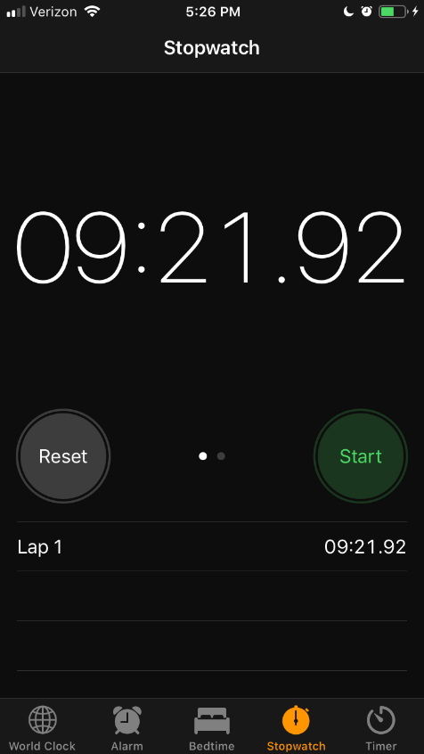

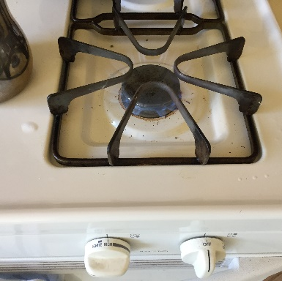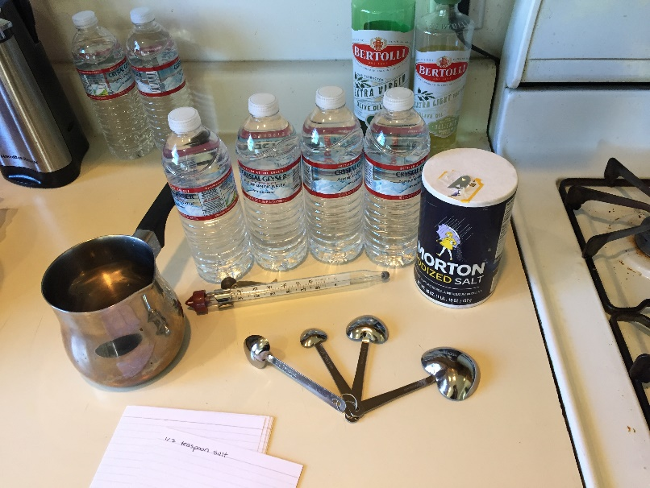

1. Four bottles that have never been opened and which contain the same kind, the same brand, and the same amount of water. For example, I’m using 4 bottles of 16.9 fl. oz Crystal Geyser ® spring water.
2. A small stainless-steel sauce pan, large enough to hold the 16.9 oz of water with about 2 inches room to allow for boiling, above the water level. I’m using this same pot for all four tests.
3. I’m using Morton ® iodized salt for all four tests.
4. I’m using a set of standard baking spoons with four measuring spoons that can hold, ¼ teaspoon, ½ teaspoon, 1 teaspoon, and 1 tablespoon.
5. A cooking thermometer with degree measurements in Fahrenheit. For example, I’m using a Taylor ® cooking thermometer with temperatures in Fahrenheit ranging from 90°F to 400°F.
6. A burner that is hot enough to boil water. For example, I am using one burner on a gas stove for all four experiments.
7. I’m using the stop watch on my iPhone.
8. Index cards or paper with a pencil to write down the time after each test and to take any notes. I found index cards to be the best option.

H. The experimental procedure which I followed is written in detail below:

1. I opened the first bottle of water and poured the entire contents into the stainless-steel pot.

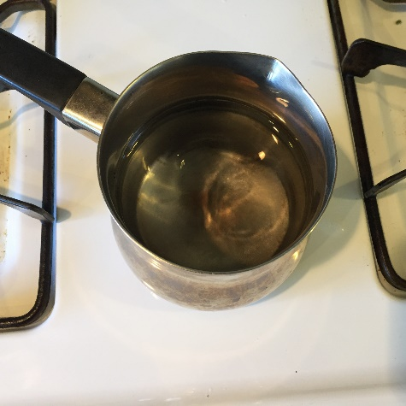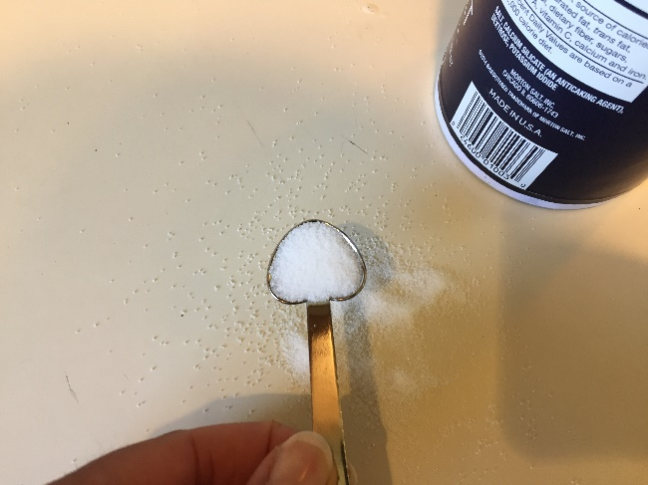

1. Then I added the first measurement of salt (1/4 teaspoon) into the water.
2. I turned the burner on high before placing the pot of water on it.
3. Then I got the timer ready. I made sure that my iPhone timer app was open and that all I had to do was press start on the timer.
4. Then with my right hand I placed the pot on the burner as I simultaneously pressed start on the timer app, with my left hand.
5. I then placed the thermometer inside the water and waited until the temperature reached boiling point (212°F) and the water began to boil.

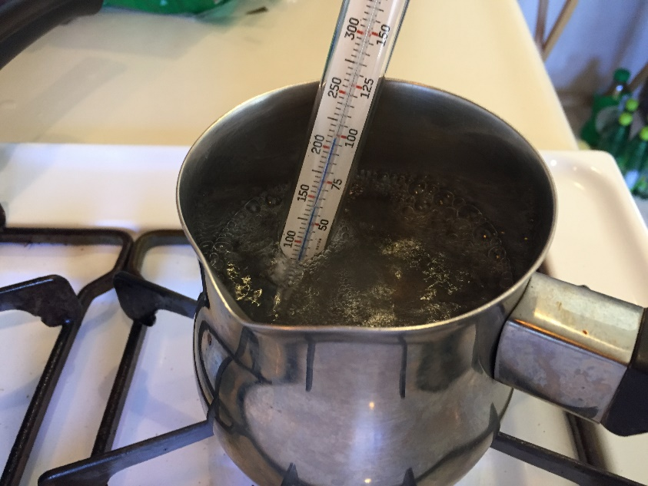

1. As soon as the water began to boil and the thermometer was reading at least 212°F, I pressed the stop button on the timer app.
2. Then I wrote down the time for this first test, onto an index card.
3. Next, I poured out the hot water and rinsed the pot in the sink with cool water, keeping the burner turned on high for the next test.

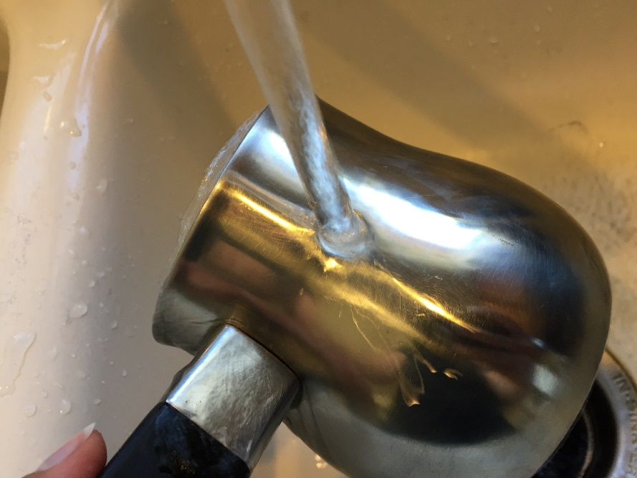

1. Next, I dried the outside of the pot and prepared it for the next test.

For the next three tests, I repeated steps 1 through 10 exactly *except* that *I changed the amount of salt* for each one. So, for the four tests, the four amounts of salt used were ¼ teaspoon, ½ teaspoon, 1 teaspoon, and 1 tablespoon.

Section IV: Result

1. The results from the four tests are as follows:
2. Test one using ¼ teaspoon of salt took 9 minutes and 17 seconds to reach boiling point.
3. Test two using ½ teaspoon of salt took 8 minutes and 29 seconds to reach boiling point.
4. Test three using 1 teaspoon of salt took 9 minutes and 4 seconds to reach boiling point.
5. Test four using 1 tablespoon of salt took 9 minutes and 21 seconds to reach boiling point.
6. The first test, with the least amount of salt took longer than tests two and three, which contradicts my hypothesis. However, setting the first test aside, the other three tests show that the water which had more salt in it did indeed *take longer to boil,* which is in alignment with the hypothesis.

J. Most of the results confirm my hypothesis. The four results are displayed below.

|  |  |  |  |  |
| --- | --- | --- | --- | --- |
| Tests | Salt amount  (Independent) | Water amount  (Dependent) | Time to boil | Aligns with hypothesis |
| Test 1 | ¼ teaspoon | 16.9 fl. oz | 09:17 | No |
| Test 2 | ½ teaspoon | 16.9 fl. oz | 08:29 | Yes |
| Test 3 | 1 teaspoon | 16.9 fl. oz | 09:04 | Yes |
| Test 4 | 1 tablespoon | 16.9 fl. oz | 09:21 | Yes |

**Section V: Conclusions**

K.  The hypothesis was partially confirmed by this experiment. The first test, which used ¼ teaspoon of salt, reached boiling point faster than steps two and three. However, putting step one aside, steps 2-4 align with the hypothesis and the results of the experiment show that those tests which added larger amounts of salt to the water boiled faster than those with lesser amounts of salt.

L.  It seems that room temperature in the kitchen became higher after the first experiment due to the heat from the burner. The burner on the stove was on constantly during the entire experiment, which may have manipulated the length of time it took the water to boil for all four tests. This means that the starting temperature of the water in the bottles could have been higher because of the increased room temperature. Turning off the burner between each experiment while preparing the next one, could have helped to control the room temperature and therefore improve the results of this experiment.

M.  My results are consistent with the literature review which explains that adding salt to water makes water take a longer time to boil.

**Section VI: Sources**

N.

Helmenstine, A. 2018. Why Do You Add Salt to Boiling Water? Retrieved from: https://www.thoughtco.com/adding-salt-to-boiling-water-607427

Kruszelnicki, K. 2019. Salt in water. Retrieved from: <http://www.abc.net.au/science/articles/2007/04/12/1894612.htm>